SHORT DESCRIPTION OF OUR CITY AND OUR SCHOOL
General Information about Cluj-Napoca

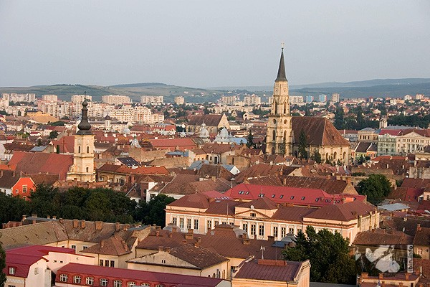

The Municipality of Cluj-Napoca is the seat of Cluj County and the spiritual and economic capital of Transylvania as well as an influential academic and medical centre; the heart of multiculturalism and diversity, Cluj is the city where the past, the present and the future forged the identity and local specifics.
The municipality has a population of 311.400. The population of the Cluj-Napoca metropolitan area, as proposed by the current project is estimated at 360,000. Finally the population of the influence area counts over 400 thousand residents.
Cluj-Napoca – the treasure city is therefore an urban republic, a homeland for its inhabitants, a city where the organization of local administration, the proper distribution of taxes, the public order and urban development were, most of the time, more important than European events or princes' politics. Although Cluj-Napoca citizens spoke different languages, they knew how to live together in harmony, to mutually accept and respect the values of a city which always hosted different ethnics, religions and social classes. For these reasons, the most valuable and sustainable richness of the treasure city is that remarkable art of living together.
Cluj-Napoca is today one of the most important academic, cultural, industrial and business centers in Romania. Among others, it hosts the largest university in the country, the Babes-Bolyai University, state-renowned cultural institution.
The various cultural and material influences, which left their mark on Transylvania’s history, made up an important cultural and historic legacy of monuments, ancient vestiges or medieval churches and cathedrals at the side of modern masterpieces, as well as museums, memorial houses and architecture monuments.

“Napoca” Technical College

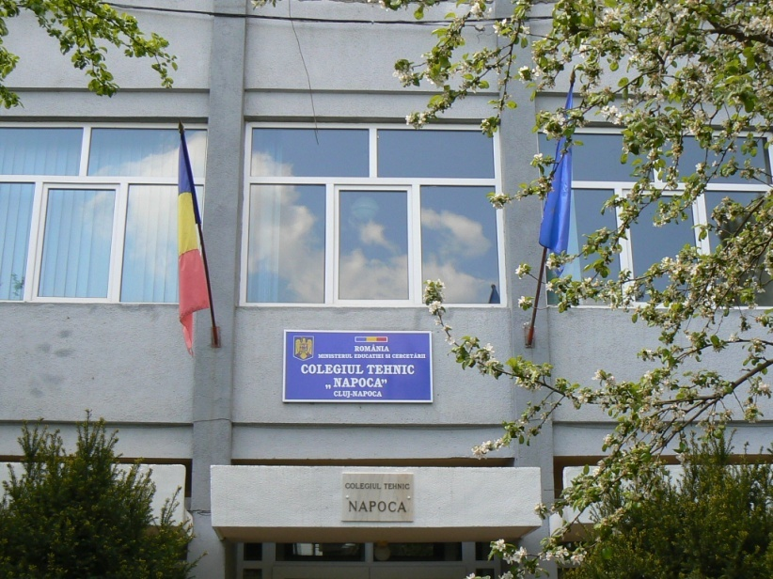

Starting as a Technical Secondary School with leather sections in 1946, “Napoca” Technical College has 65 years of activity representing tradition, continuity and certainty of the future.
Located in a neighbourhood spread over a large area, “Napoca” Technical College remains a school with vocational and technical tradition in Cluj. Its unique profile of Fashion Designers makes it have a very special status over the years.
"Napoca" Technical College has a number of over 650 students, attending both day and night classes and a well-prepared and motivated team of teachers, with important results in their specialties and various extra curricular activities. Students are taught and trained as tourism technicians and fashion designers.
Today, in a competitive environment, students are offered a qualitative technical education for keeping on their studies in universities or finding a job after graduation.
Fashion design and latest tourism services are areas where talent and imagination correlated with a qualitative professional training inspire the others.
Facilities: over 22 newly-furnished classrooms and laboratories, school workhouses, medical and psychological cabinet, library, hostel, cafeteria, festivities room, sport hall.
POZE

