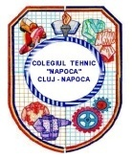 | NAPOCA” TECHNICAL COLLEGE  CLUJ-NAPOCA, ROMANIA 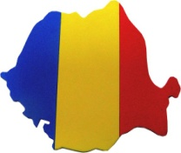

SCHOOL DESCRIPTION

Starting as a Technical Secondary School with leather sections in 1946, “Napoca” Technical College has 69 years of activity representing tradition, continuity and certainty of the future.
Located in a neighbour hood spread over a large area, “Napoca” Technical College remains a school with vocational and technical tradition in Cluj. Its unique profile of Fashion Designers makes it have a very special status over the years.

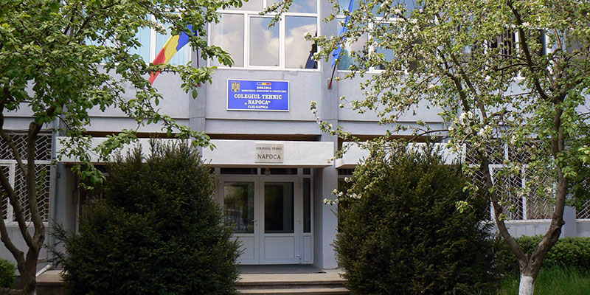

Napoca" Technical College has a number of over 650 students, attending both day and night classes and a well-prepared and motivated team of teachers, with important results in their specialties and various extra curricular activities. Students are taught and trained as tourism technicians and fashion designers.
Today, in a competitive environment, students are offered a qualitative technical education for keeping on their studies in universities or finding a job after graduation.
Fashion design and latest tourism services are areas where talent and imagination correlated with a qualitative professional training inspire the others.
Our school is involved in projects under national and operational programs and projects under EU programs. The student’s participation in projects and extracurricular activities motivates them to achieve their potential and participate actively in the learning process.
Like many school from our country, many of our students come from poor families or have unemployed parents and they live with grandparents or alone because their parents work abroad. For this reason we have some students who has risk for early leaving school. This european project help us and our students to develop such kind of activities which is useful for their behavior.
Our task in this project is to purpose acitivities which develop spatial intelligence under the title “Just like lifelike”. That means how to transform a clasic teaching into a applicative teaching.

Just Like Lifelike

Lifelike experience is an idea which has evolved since the time when a painting was considered lifelike. Leonardo da Vinci’s Mona Lisa is famous for the ambiguity of the subject's expression, the monumentality of the composition, and the subtle modeling of forms and atmospheric illusionism which contributed to the continuing fascination of the work. A whole painting technique has been created pursuing the goal of the lifelike art form, called trompe-l'œil, involving extremely realistic imagery in order to create the optical illusion that the depicted objects appear in three dimensions.

SPATIAL INTELLIGENCE

Gardner’s theory of Multiple Intelligence proposes that there are eight different and discrete facets of cognition, which can be regarded as relatively autonomous human intelligences: logical- mathematical, linguistic, musical, spatial, bodily- kinesthetic, interpersonal, intrapersonal and naturalistic.
Spatial intelligence is the brain’s ability to perceive and interpret visual stimuli. In order words, it’s how our minds process what we see. Also not very recognized spatial intelligence is very important in the arts and in everyday life.

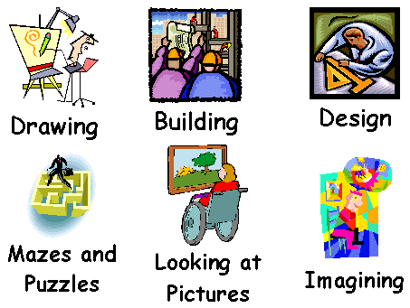
WHY IS SPATIAL INTELLIGENCE IMPORTANT?

The way that we visually perceive and interpret de world around us is an important quality to have. In the arts, the ability to transfer a vision to a painting. Sculpture, or film is a key quality. Careers such as architecture, require a person to transfer a vision of a structure in to a blueprint. Spatial intelligence is even used by average people to remember small, but important facts like how to travel from your school to your house. Everyone uses spatial intelligence in everyday life.

POSSIBLE CAREERS

- Advertising agent
- Architect
- Cartographer
- Drafter
- Engineer
- Fine artist
- Graphic designer
- Fashion designer
- Interior designer
- Inventor
- Painter
- Photographer
- Pilot
- Sculptor
- Surveyor
- Urban planner

FAMOUS PEOPLE WITH HIGH SPATIAL INTELLIGENCE

- Leonardo da Vinci
- Pablo Picasso
- Vincent van Gogh
- Frank Lloyd Wright
- Steven Spielberg
- Amelia Aerhart
- Auguste Rodin
- Robert Fulton
- Michelangelo

How to develop spatial intelligence

Gardner’s developmental trajectory of intelligence provides an insight into the four stage development of spatial intelligence across the lifespan.
- Stage 1: Raw patterning Ability
Here we can sustain interest in a variety of spatial activities since an early age like: drawing, puzzles, construction activities etc.
- Stage 2: Understanding a symbol system
At this stage we develop student’s visualization of unseen object and spatial technique to depict that unseen information. The skills needed to create and interpret spatial symbol systems are: eye-motor coordination, figure-ground perception, perceptual constancy, position-in-space perception, perception of spatial relationship, visual discrimination, visual memory.
- Stage 3: Use of a notational system
The students can develop their ability to make sketches and symbolize on this something they didn’t draw or to symbolize every element of sketches. Also they need to be able to interpret two-dimensional plans or three-dimensional objects and to construct three-dimensional object from a plan.
- Stage 4: Vocational pursuits
Our students can creating dynamic patterns using computer software paint programs. The opportunities may arise by exposing students to careers and leisure activities that are of interested.

LESSON PLANNING ACTIVITIES FOR SPATIAL INTELLIGENCE

- Brochures
- Collages
- Designs
- Drawings
- Flowcharts
- Mapping
- Patterns
- Painting
- Photography
- Posters
- Sculpting
- Ideas sketching

EXAMPLE OF ACTIVITIES IN OUR SCHOOL

- FOR FASHION DESIGN FIELD
Our students from fashion design learn how to transform a fashion sketch ]n a final product (dress, skirt, trouser etc.).

How to draw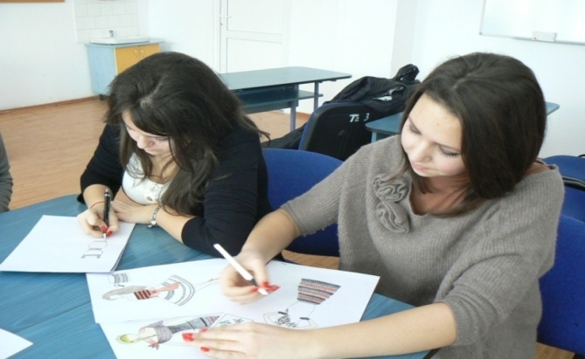 a fashion sketch | 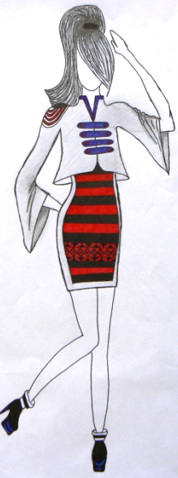 Fashion sketch
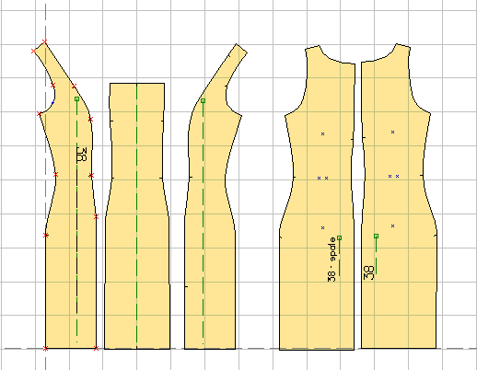  Clothing Patterns | 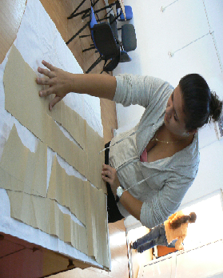Settlement patterns and cutting

A nice dress (final product)

- FOR TOURISM FIELD
Our students from tourism field learn how to make decorative elements for hotel rooms make by towels and how to make a friendly ambient for reastaurant.

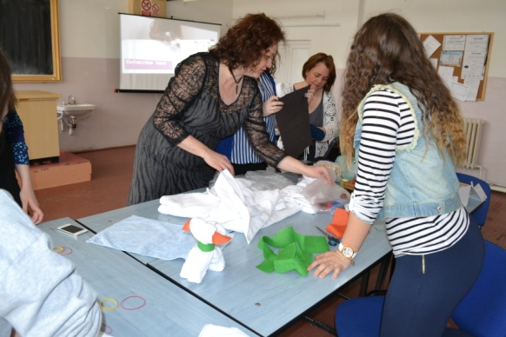  How to make a swan | 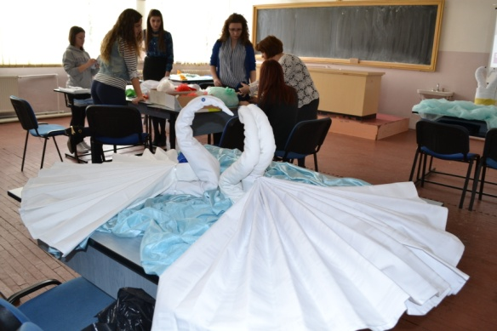  Here is two swans
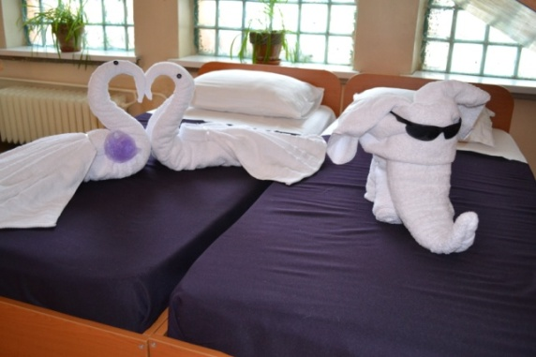  Bed decorations | 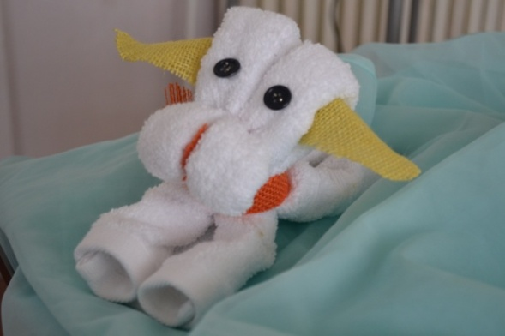  Here is a puppy
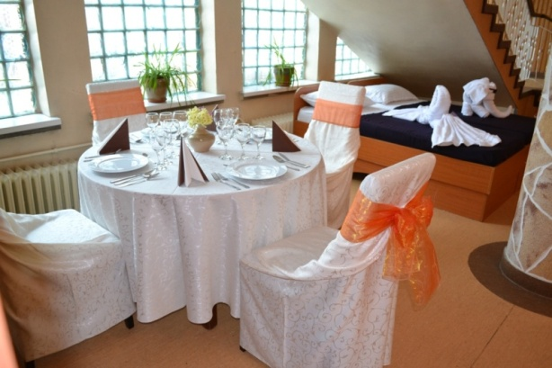

Mise-en- place

- How to make a special clothes using reusable materials ( plastic, paper etc.)

Our teachers try to develop creativity of our students, They can create many interesting things by using unusual materials. They create dresses from recyclable materials which look like any other dresses. With their fashion collection our students participate at many national competition.

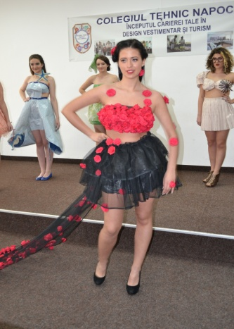 | 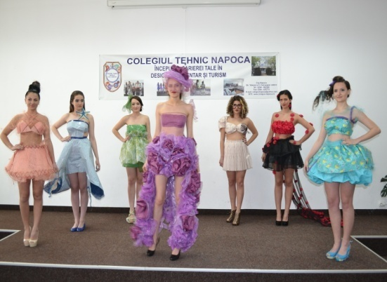 | 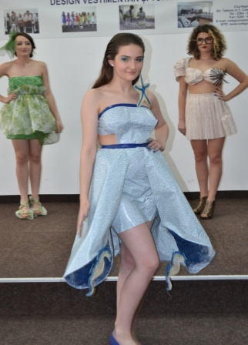
CONCLUSION

Teachers at all stages of education need to reflect on their practice and beliefs about spatial intelligence in order to optimize opportunities for children to utilize and develop this intelligence. Teachers and curriculum developers must to accord much more importance to promote spatial intelligence in relation to logico-mathematical and linguistic intelligence. This kind of intelligence could be develop in informal and formal learning environments.

References:
- Gardner, Howard (1993), Multiple Intelligences: The Theory in Practice, Basic Books, ISBN 046501822X
- Davis, Katie; Christodoulou, Joanna; Seider, Scott; Gardner, Howard (2011), "The Theory of Multiple Intelligences", in Sternberg, Robert J.; Kaufman, Barry, The Cambridge Handbook of Intelligence, Cambridge University Press, pp. 485–503, ISBN 0521518067
- wikipedia.org/wiki/Theory_of_multiple_intelligences
- http://www.infed.org/thinkers/gardner.htm

