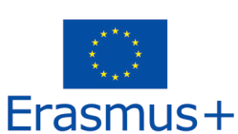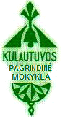

The programme of the 1th Erasmus+ project
“Let's Break The Ice With School” meeting in Lithuania
Tuesday, 16th December
12.55 – 18.00 Arrival and accommodation.
18.00 – Free time in Kaunas.
Wednesday, 17th December
9.30 Departure from the hotel.
10.00 Meeting with the Mayor Mr. Valerijus Makūnas in Kaunas Region Municipality.
11.00 Leaving to Kulautuva.
11.40 Lunch in the canteen of the school.
12.15 Concert dedicated for the guests of the school.
12.40 – 15.00 Discussing over the project activities.
13.40 Coffee break for teachers.
15.00 Leaving to Kaunas.
Visiting the old town of Kaunas, Liberty Avenue (Lithuanian: Laisvės Alėja), Žilinskas Gallery.
18.00 Dinner in Kaunas Akropolis, the shopping and entertainment centre. Free time activities.

Thursday, 18th December
9.00 Leaving to Vilnius (from Kaunas).
11.00 A guided tour in National Museum Palace of the Grand Dukes of Lithuania in Vilnius.
12.30 Visiting the Catacombs of Vilnius Cathedrial.
13.30 – 16.00 Lunch and free time in Vilnius old town.
16.30 Leaving to Kaunas.
19.20 Leaving from Kaunas to Kulautuva.

20.00 A farewell party in Gojus, Kulautuva with traditional Lithuanian meals, national songs, dance, games and communication. Remember to revise national songs

Friday, 19th December
09.00 Leaving from Kaunas to Vilnius airport.

